**Date: BPO MANAGEMENT SYSTEM**

**Ex: No:**

**AIM:**

To Design ,Implement and Test the BPO Management System described in the given problem statement .

**PROBLEM STATEMENT**

In this BPO inbound system, the process undergoing is that the agent tries to sell his product so that the agent gets the details of the customer from the database and pitches about his product and makes the sales successful. The communication is done through the telephone. Telephone is the major component used for this customer satisfaction service .This software is designed to know about the processes that were taking place in the BPO office. This system holds the details of the customer who and all approaches to it. It is managed by the central system. With the reduction in communication costs and improved bandwidths and associated infrastructure, BPO as a segment is witnessing a massive growth. One of the key challenges that BPO companies that provide data entry/data validation services is an efficient and effective way of getting the source documents from different customers and accurately route the same to different operators for processing.

**USECASE DIAGRAM:**

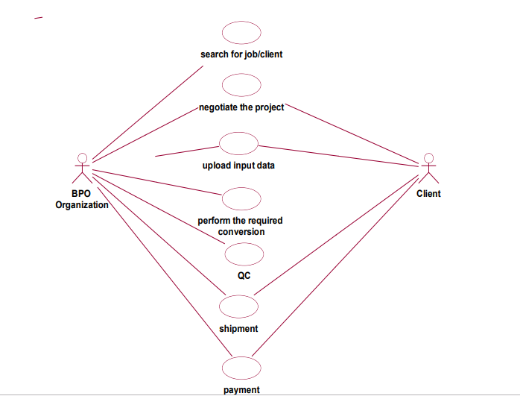

**CLASS DIAGRAM:**

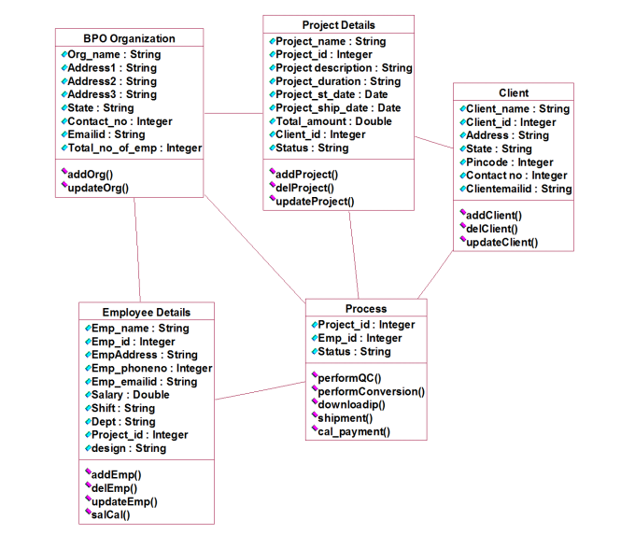

**SEQUENCE DIAGRAM:**

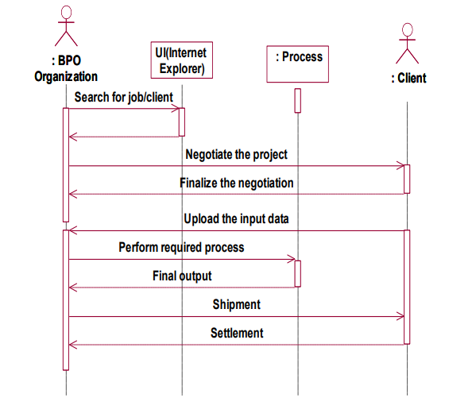

**ACTIVITY DIAGRAM:**

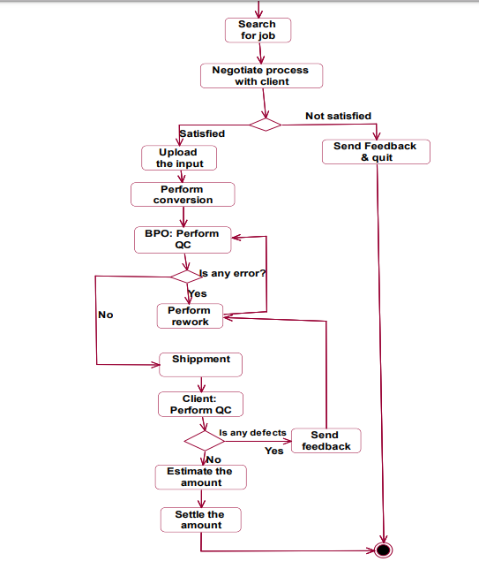

**STATE CHART DIAGRAM:**

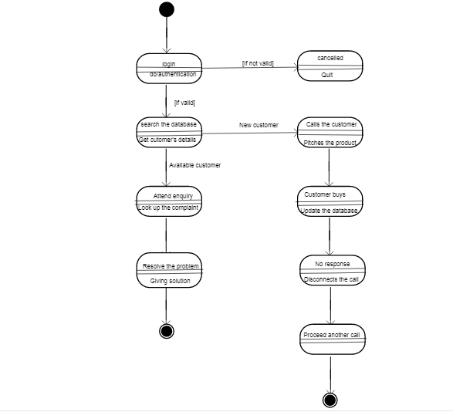

**COMPONENT DIAGRAM:**

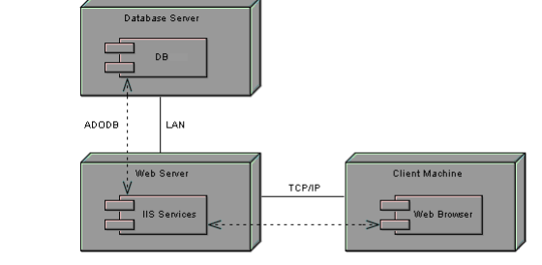

**DEPLOYMENT DIAGRAM:**

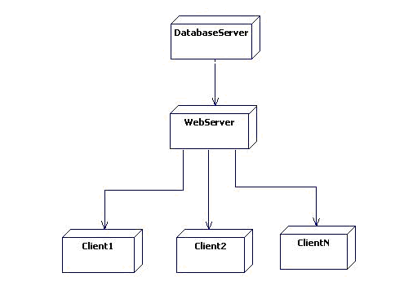

**IMPLEMENTATION & TESTING**

import java.util.Scanner;

import java.util.Timer;

import java.util.TimerTask;

/*

* To change this license header, choose License Headers in Project Properties.

* To change this template file, choose Tools | Templates

* and open the template in the editor.

*/

/**

*

* @author GOMATHI

*/

//global static int empid=0,projectid=0;

public class bposystem {

String bponame,address,email,state,contact_no;

int noofemp;

Scanner sc= new Scanner(System.in);

public void addbpodetails()

{

System.out.println("Enter the BPO Name");

bponame=sc.nextLine();

System.out.println("Enter the address");

address=sc.nextLine();

System.out.println("Enter your statename");

state=sc.nextLine();

System.out.println("Enter your Contact No");

contact_no=sc.nextLine();

System.out.println("Enter your Number of Employees");

noofemp=sc.nextInt();

}

public void update()

{

int choice;

System.out.println("Which details you want to update");

System.out.println("1. Name of Organization 2. Address 3. State 4. Contact No ");

System.out.println("Press the Menu Number to update");

choice= sc.nextInt();

switch(choice)

{

case 1:

System.out.println("ENTER YOUR NEW NAME OF ORGANIZATION");

bponame=sc.nextLine();

break;

case 2:

System.out.println("ENTER YOUR NEW ADDRESS");

address=sc.nextLine();

break;

case 3:

System.out.println("ENTER THE NEW STATE");

state=sc.nextLine();

break;

case 4:

System.out.println("ENTER YOUR NEW CONTACT NUMBER");

contact_no=sc.nextLine();

break;

default:

System.out.println("All changes get updated ");

break;

}

}

}

class employeedetails

{

Scanner sc= new Scanner(System.in);

String empname, empadd,empphoneno,dept,shift;

int salary;

public static int empid=0,projectid=0;

public void addemployeedetails()

{

empid+=1;

System.out.println("Enter employeename");

empname=sc.nextLine();

System.out.println("Enter employee address");

empadd=sc.nextLine();

System.out.println("Enter your employee Phone Number");

empphoneno=sc.nextLine();

System.out.println("Ente the department");

dept=sc.nextLine();

System.out.println("Enter the shift");

shift=sc.nextLine();

System.out.println("Enter the salary");

salary=sc.nextInt();

System.out.println("Enter your project id");

projectid=projectid+1;

}

public void salcal()

{

salary=salary+100*projectid;

System.out.println("The salary of employee is"+salary);

}

}

class project

{

Scanner sc= new Scanner(System.in);

String projectname,projectdes,projectduration,status,startdate,shipdate;

public static int projectid=0;

int amount, clientid;

public void addproject()

{

System.out.println("Enter your Project Name");

projectname=sc.nextLine();

projectid+=1;

System.out.println("Enter your Project Description");

projectdes=sc.nextLine();

System.out.println("Enter your Project Duration");

projectduration=sc.nextLine();

System.out.println("Enter your Project Startdate. Enter in this format DD/MM/YY");

startdate=sc.nextLine();

System.out.println("Enter your Project Shipdate. Enter in this format DD/MM/YY");

shipdate=sc.nextLine();

System.out.println("Enter the amount");

amount=sc.nextInt();

System.out.println("Enter the client id");

clientid=sc.nextInt();

//System.out.println("Enter the status");

//status=sc.nextLine();

}

}

class client

{

Scanner sc= new Scanner(System.in);

String clientname, address, state, pincode,contactno,mailid;

public static int clientid=0;

public void addclient()

{

System.out.println("Enter the client name");

clientname=sc.nextLine();

//System.out.println("Enter the client id");

clientid+=1;

System.out.println("Enter the client address");

address=sc.nextLine();

System.out.println("Enter the client State");

state=sc.nextLine();

System.out.println("Enter the client pincode");

pincode=sc.nextLine();

System.out.println("Enter the client contactno");

contactno=sc.nextLine();

System.out.println("Enter the client mailid");

mailid=sc.nextLine();

}

}

class process {

Scanner sc=new Scanner(System.in);

public void queries(String projectna, String projectdes, String projectdur)

{

System.out.println("****Queries Panel****");

System.out.println("What is the Project Name?");

System.out.println("Project Name is: "+projectna);

System.out.println("What is the Project Name?");

System.out.println("Project Description is: "+projectdes);

System.out.println("What is the Project Duration?");

System.out.println("Project Duration is: "+projectdur);

}

public void conversation()

{

System.out.println("Speak with the client...");

Timer timer=new Timer();

timer.schedule(new TimerTask(){

@Override

public void run()

{

System.out.println("Conversation going on...");

}

},4500);

}

public void shipment(String ship)

{

String reason;

int ch,ch1;

System.out.println("Shipment date"+ship);

System.out.println("IF PROJECT HAS BEEN COMPLETED PRESS 1 OR ELSE PRESS 0");

ch=sc.nextInt();

if(ch==1)

{

System.out.println("Project has been successfully completed");

System.out.println("Press 1 to export the project to client");

ch1=sc.nextInt();

if(ch1==1)

{

System.out.println("Project has been successfully exported.");

System.out.println("Payment will be done within 12 hours to your account");

}

else

{ }

}

else

{

System.out.println("Project has been delayed");

System.out.println("Enter the reason for delay");

reason=sc.nextLine();

System.out.println("Penalty will be imposed for each day of delay. 1 day Rs.1000 will be deduced from the amount ");

}

}

public void calpayment(int amt)

{

int daysdelay,payment,bonus=100;

System.out.println("Enter the total delay in time");

daysdelay=sc.nextInt();

System.out.println("amount is "+amt);

if(daysdelay==0)

{

payment=amt*bonus;

}

else

{

payment=amt-daysdelay*1000;

}

System.out.println("Final amount payed"+payment);

}

}

class start extends project

{

public static void main(String args[])

{

bposystem bpo=new bposystem();

employeedetails emp=new employeedetails();

project prj =new project();

client clt=new client();

process pr=new process();

bpo.addbpodetails();

emp.addemployeedetails();

emp.salcal();

prj.addproject();

int am= prj.amount;

String ship=prj.shipdate;

String prjn=prj.projectname;

String prjnd=prj.projectdes;

String prjdur=prj.projectduration;

clt.addclient();

pr.queries(prjn, prjnd, prjdur);

pr.conversation();

pr.shipment(ship);

pr.calpayment(am);

}

}